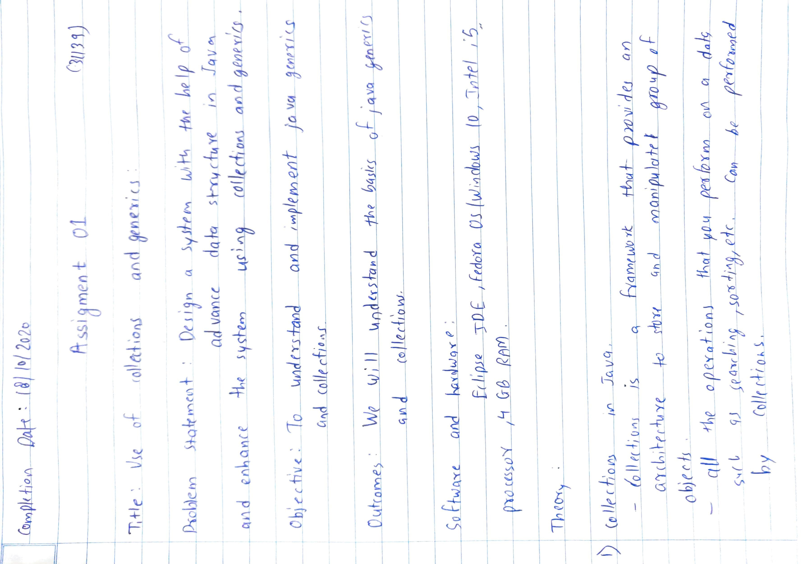

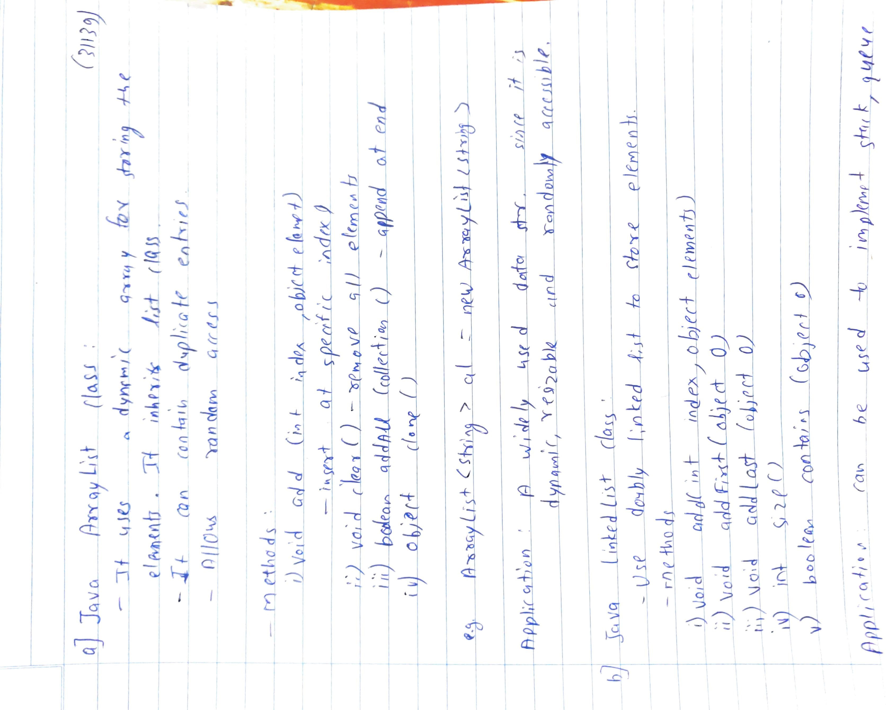

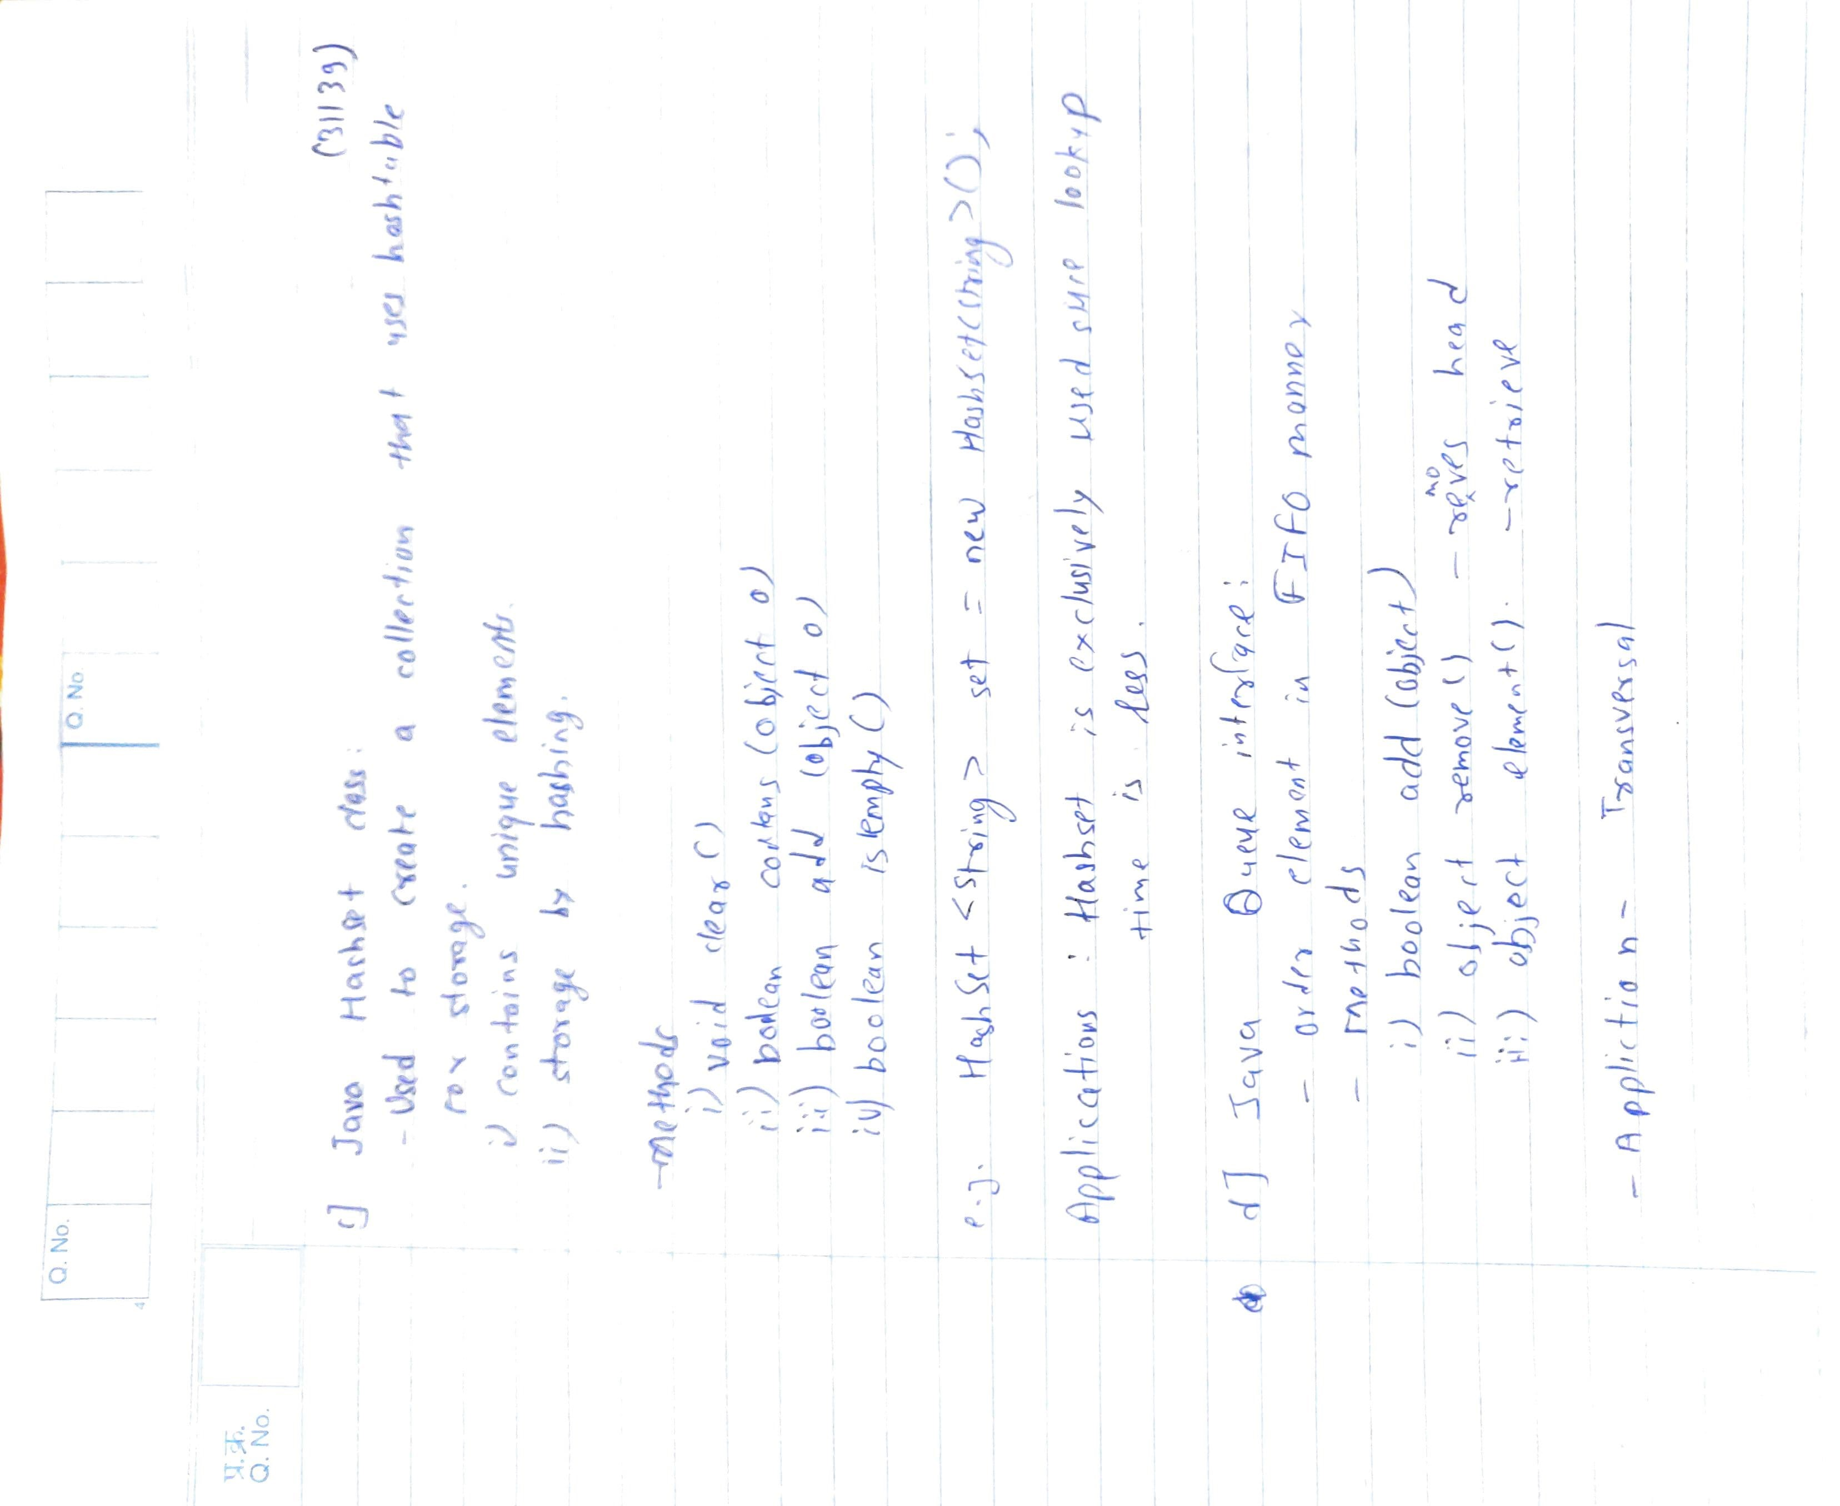

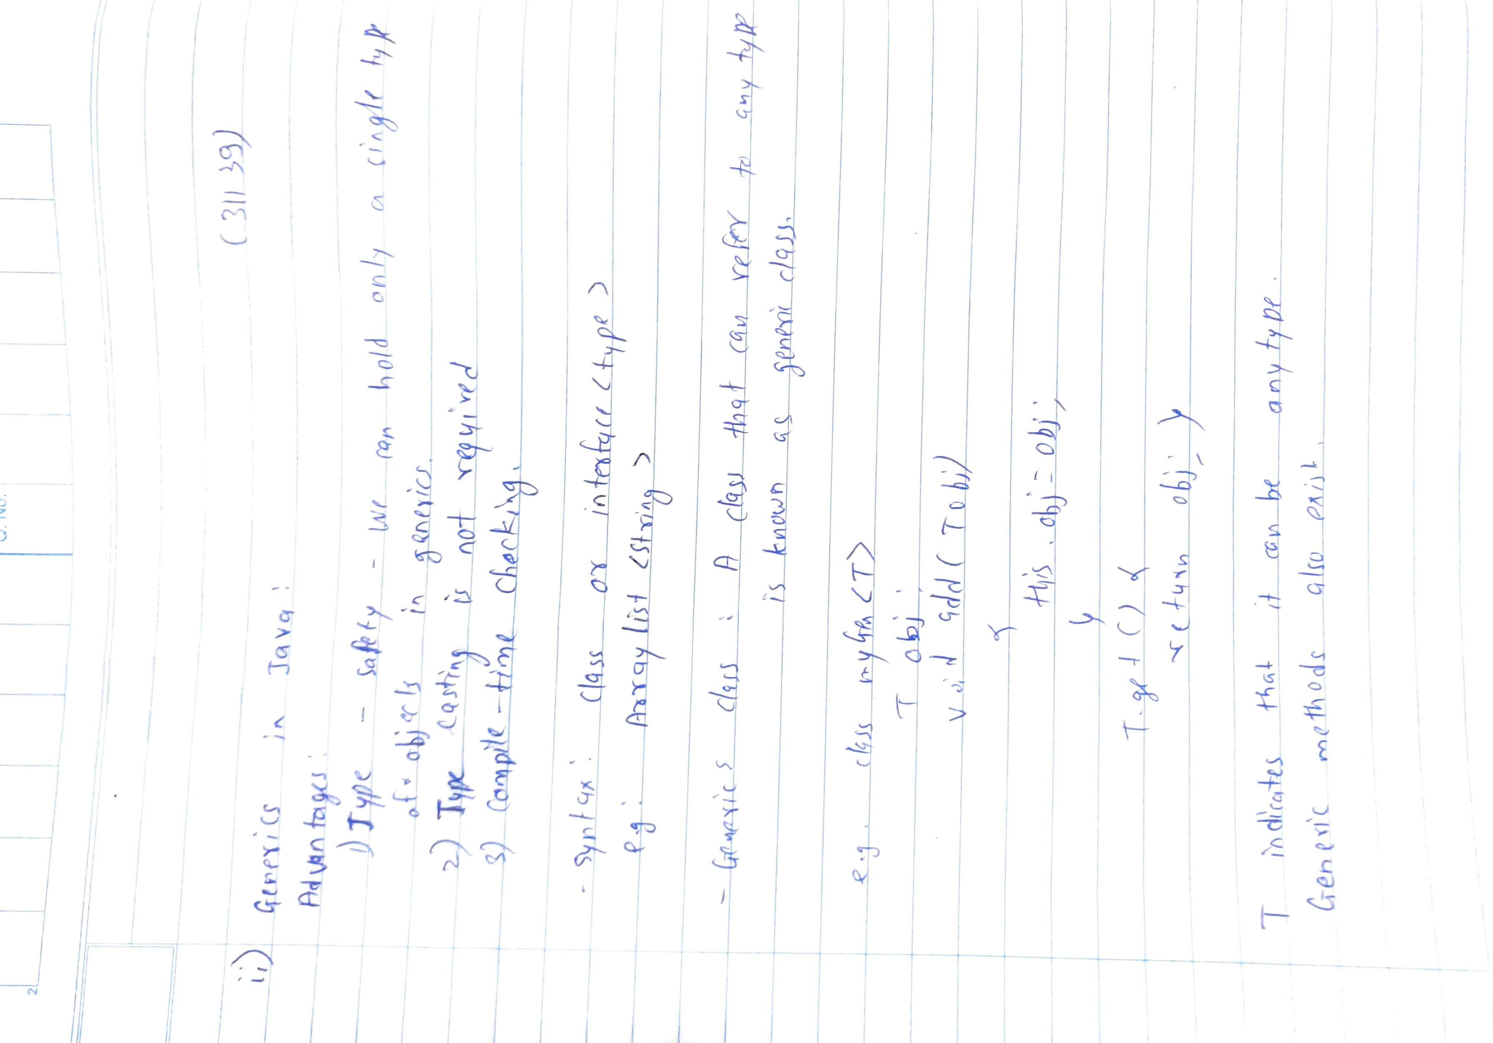

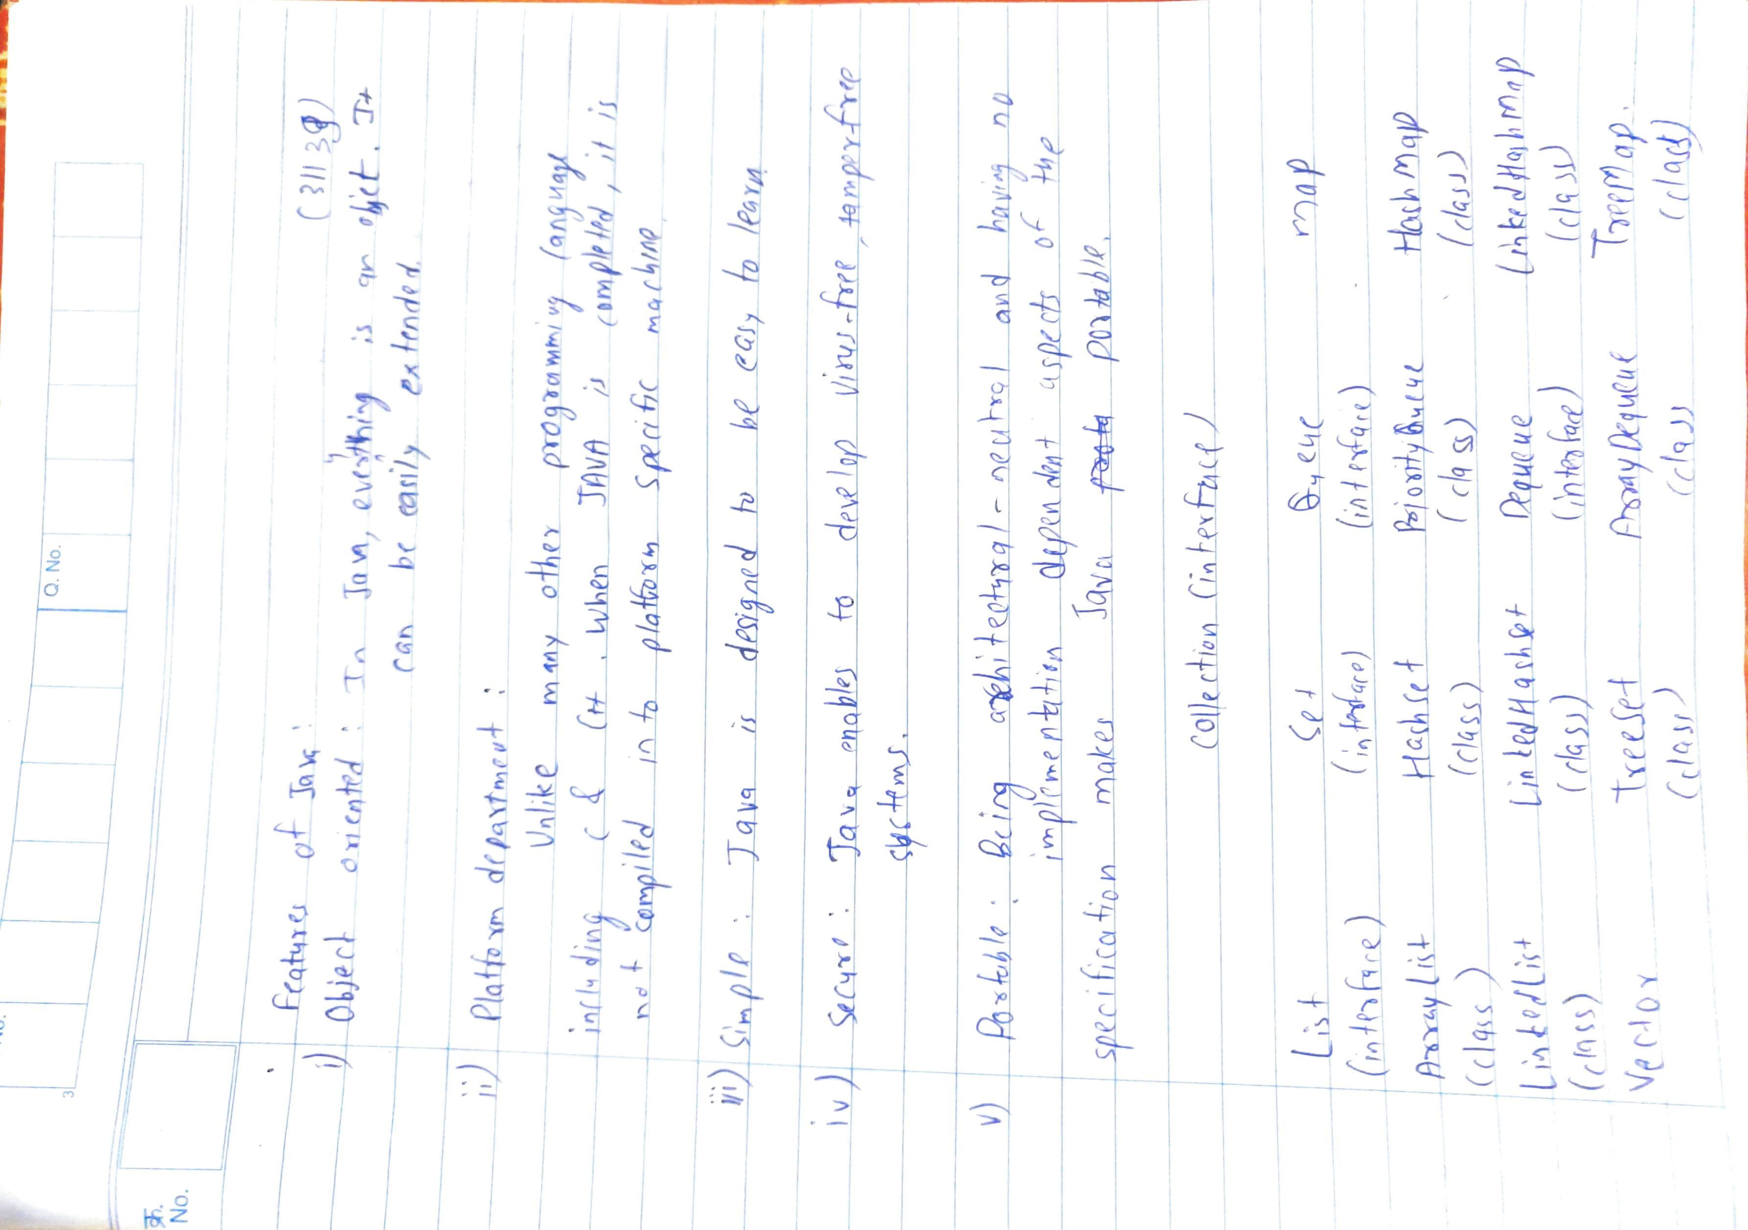

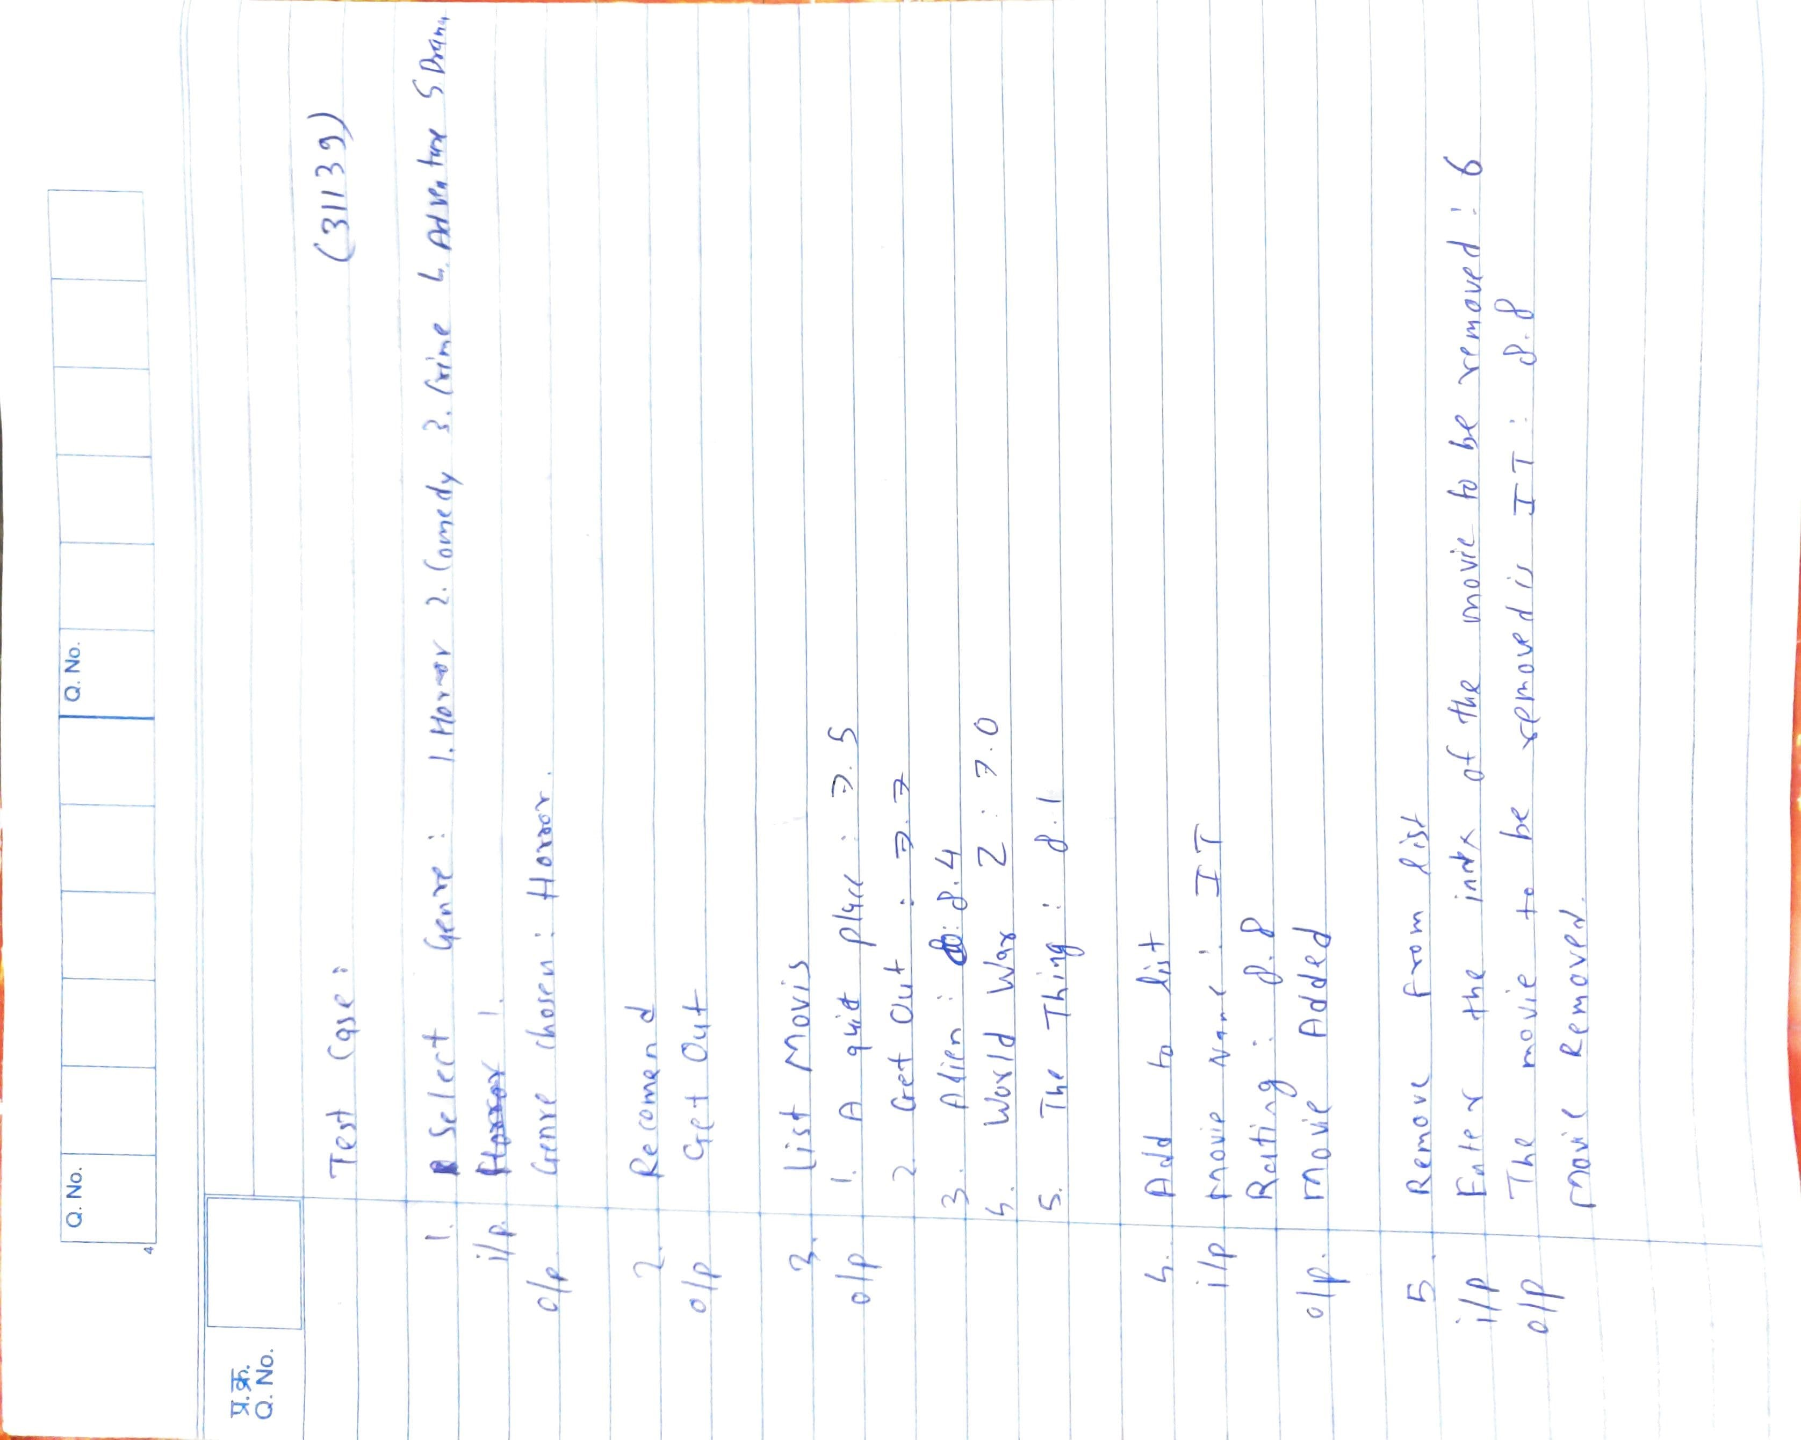

import java.util.*;

public class MovieR {

public static Genre horror = new Genre("Horror");

public static Genre comedy = new Genre("Comedy");

public static Genre crime = new Genre("Crime");

public static Genre adventure = new Genre("Adventure");

public static Genre drama = new Genre("Drama");

public static void main(String[] args) {

List<Genre> genres = new LinkedList<Genre>();

genres.add(horror); genres.add(comedy); genres.add(crime); genres.add(adventure); genres.add(drama);

dummyClass dc = new dummyClass();

dc.addDummyData();

Scanner input = new Scanner(System.in);

while(true){

int genre_no;

System.out.println("\n-------------------------------------------------------\n\t\tWELCOME\n-------------------------------------------------------");

System.out.println("Select Genre from the following:-\n1.Horror\t2.Comedy\t3.Crime\t\t4.Adventure\t5.Drama\t\t6.Exit the program");

genre_no = input.nextInt();

if(genre_no==6){

input.close();

break;

}

System.out.println("Genre Chosen: "+genres.get(genre_no-1).getName());

Genre chosen_genre = genres.get(genre_no-1);

int choice;

System.out.println("1.Recommend\t2.List movies\t3.Add to list\t4.Remove from list");

choice = input.nextInt();

int listsize = chosen_genre.movielist.size();

System.out.println("");

switch (choice) {

case 1:

Random rand = new Random();

int index = rand.nextInt(listsize);

chosen_genre.recommendMovie(index);

break;

case 2:

chosen_genre.printMovies();

break;

case 3:

System.out.println("Enter Movie Name: ");

Scanner s = new Scanner(System.in);

String name = s.nextLine();

System.out.print("Enter Rating: ");

double rating = input.nextDouble();

chosen_genre.addMovie(name, rating);

System.out.println("Movie Added");

break;

case 4:

System.out.println("The movies are as following:-");

chosen_genre.printMovies();

System.out.print("Enter the index of the movie to be removed: ");

int movieindex = input.nextInt();

if(movieindex>listsize || movieindex< 0){

System.out.println("Enter valid index");

// continue;

}

chosen_genre.removeMovie(movieindex-1);

break;

default:

System.out.println("Enter valid Input");

break;

}

}

input.close();

}

};

class Genre{

String name;

List<Movie> movielist = new Vector<Movie>();

Genre(){}

Genre(String Name){

name = Name;

}

public String getName(){

return name;

}

public String addMovie(String name, double rating){

movielist.add(new Movie(name,rating));

return movielist.get(movielist.size()-1).toString();

}

public void removeMovie(int index){

System.out.println("The movie to be removed is: "+movielist.get(index).toString());

movielist.remove((index));

System.out.println("Movie removed\n");

}

public void recommendMovie(int index){

System.out.println("Recommended Movie: \n"+ movielist.get(index).getMovieName()+"\n");

}

public void printMovies(){

for(int i = 0; i < movielist.size(); i++){

System.out.println((i+1)+". " +(movielist.get(i).toString()));

}

System.out.println("");

}

};

class Movie{

String name;

double rating;

Movie(String Name, double Rating){

name = Name;

rating = Rating;

}

public String getMovieName(){return name;}

public double getRating(){return rating;}

public String toString() {

return (name + " : " + rating);

}

};

class dummyClass{

public void addDummyData(){

MovieR.horror.addMovie("A quiet place",7.5);

MovieR.horror.addMovie("Get out",7.7);

MovieR.horror.addMovie("Alien",8.4);

MovieR.horror.addMovie("World War Z",7);

MovieR.horror.addMovie("The Thing",8.1);

MovieR.comedy.addMovie("Step Brothers",6.9);

MovieR.comedy.addMovie("White Chicks",5.6);

MovieR.comedy.addMovie("The Hot chick",5.5);

MovieR.comedy.addMovie("The Hangover",7.7);

MovieR.comedy.addMovie("Horrible Bosses",6.9);

MovieR.crime.addMovie("Project Power",6.0);

MovieR.crime.addMovie("The Tax Collector",4.7);

MovieR.crime.addMovie("The Devil All the time",6.9);

MovieR.crime.addMovie("Knives Out",7.9);

MovieR.crime.addMovie("Joker",8.5);

MovieR.adventure.addMovie("Mulan",6.9);

MovieR.adventure.addMovie("The Old Guard",6.7);

MovieR.adventure.addMovie("Dune",2020);

MovieR.adventure.addMovie("Jurassic Park",8.1);

MovieR.adventure.addMovie("Wonder Woman 1984",6.9);

MovieR.drama.addMovie("Titanic",7.8);

MovieR.drama.addMovie("Tristan & Isolde",6.8);

MovieR.drama.addMovie("Dangerous Beauty",7.2);

MovieR.drama.addMovie("Head in the clouds",6.6);

MovieR.drama.addMovie("Captain Corelli's Mandolin",5.9);

}

}

